43.74: 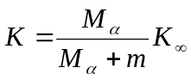, where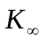 is the energy that the -particle would have if the nucleus were infinitely massive. Then, 